**Lab 1: Understanding ORM with a Retail Inventory System**

**Scenario:** You’re building an inventory management system for a retail store. The store wants to track products, categories, and stock levels in a SQL Server database.

**Objective:** Understand what ORM is and how EF Core helps bridge the gap between C# objects and relational tables.

**Steps:**

1. **What is ORM?**

• Explain how ORM maps C# classes to database tables.

• Benefits: Productivity, maintainability, and abstraction from SQL.

2. **EF Core vs EF Framework:**

• EF Core is cross-platform, lightweight, and supports modern features like

LINQ, async queries, and compiled queries.

• EF Framework (EF6) is Windows-only and more mature but less flexible.

3. **EF Core 8.0 Features:**

• JSON column mapping.

• Improved performance with compiled models.

• Interceptors and better bulk operations.

4. **Create a .NET Console App:**

dotnet new console -n RetailInventory cd RetailInventory

**5. Install EF Core Packages:**

dotnet add package Microsoft.EntityFrameworkCore.SqlServer

dotnet add package Microsoft.EntityFrameworkCore.Design

**How ORM Maps C# Classes to Database Tables**

* **ORM (Object-Relational Mapping)** connects object-oriented programming languages like C# with relational databases.
* Each **C# class** maps to a **database table**.
* Each **property** in the class becomes a **column** in the table.
* Each **object instance** represents a **row** in the corresponding table.
* Properties named Id or ClassNameId are automatically treated as **primary keys**.
* **Navigation properties** represent **relationships** (e.g., one-to-many, many-to-many) and are mapped using **foreign keys**.
* Developers can use **data annotations** (e.g., [Key], [Required]) or **Fluent API** to customize mappings.
* The ORM handles **table creation, queries, updates, and deletions** through C# code without writing raw SQL.
* It ensures **synchronization between the object model and the database schema**.
* This abstraction improves **developer productivity**, **code maintainability**, and **reduces the need to manually handle SQL queries**.

**Implementation:**

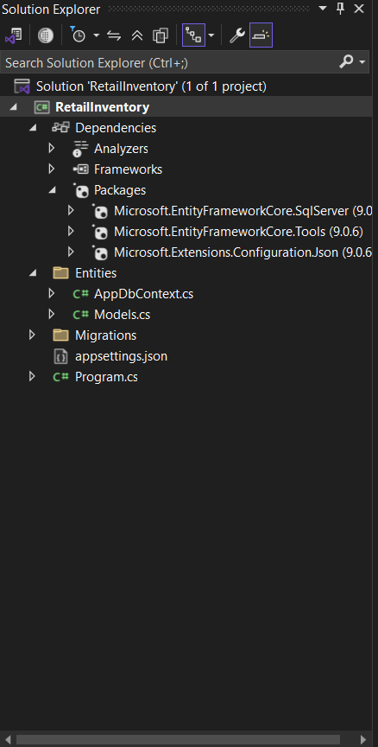

**Lab 2: Setting Up the Database Context for a Retail Store**

**Scenario:** The retail store wants to store product and category data in SQL Server.

**Objective:** Configure DbContext and connect to SQL Server.

**Steps:**

**1. Create Models:**

public class Category {

public int Id { get; set; } public string Name { get; set; } public List Products { get; set; }

}

public class Product { public int Id { get; set; }

public string Name { get; set; } public decimal Price { get; set; } public int CategoryId { get; set; } public Category Category { get; set; }

}

**2. Create AppDbContext:**

public class AppDbContext : DbContext { public DbSet Products { get; set; } public DbSet Categories { get; set; }

protected override void OnConfiguring(DbContextOptionsBuilder optionsBuild er) { optionsBuilder.UseSqlServer("Your_Connection_String_Here");

} }

**3. Add Connection String in appsettings.json (optional for ASP.NET Core)**

**Implementation:**

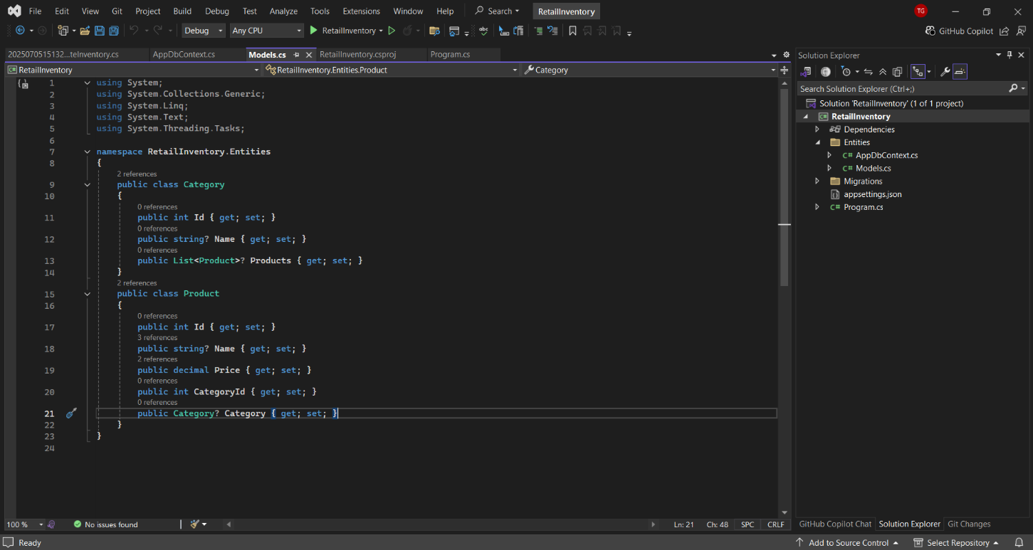

**Lab 3: Using EF Core CLI to Create and Apply Migrations**

**Scenario:** The retail store's database needs to be created based on the models you've defined. You’ll use EF Core CLI to generate and apply migrations.

**Objective:** Learn how to use EF Core CLI to manage database schema changes.

**Steps:**

**1. Install EF Core CLI (if not already):**

dotnet tool install --global dotnet-ef

**2. Create Initial Migration:**

dotnet ef migrations add InitialCreate

This generates a Migrations folder with code that represents the schema.

**3. Apply Migration to Create Database:**

dotnet ef database update

**4. Verify in SQL Server:**

Open SQL Server Management Studio (SSMS) or Azure Data Studio and confirm that tables Products and Categories are created

**Implementation:**

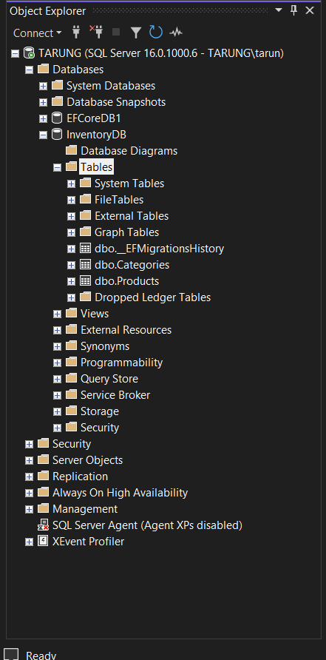

**Lab 4: Inserting Initial Data into the Database**

**Scenario:** The store manager wants to add initial product categories and products to the system.

**Objective:** Use EF Core to insert records using AddAsync and SaveChangesAsync.

**Steps:**

1. **Insert Data in Program.cs:**

using var context = new AppDbContext();

var electronics = new Category { Name = "Electronics" }; var groceries = new Category { Name = "Groceries" };

await context.Categories.AddRangeAsync(electronics, groceries);

var product1 = new Product { Name = "Laptop", Price = 75000, Category = electro nics };

var product2 = new Product { Name = "Rice Bag", Price = 1200, Category = groceri es };

await context.Products.AddRangeAsync(product1, product2); await context.SaveChangesAsync();

**2. Run the App:**

dotnet run

3. **Verify in SQL Server:**

Check that the data is inserted correctly.

**Implementation:**

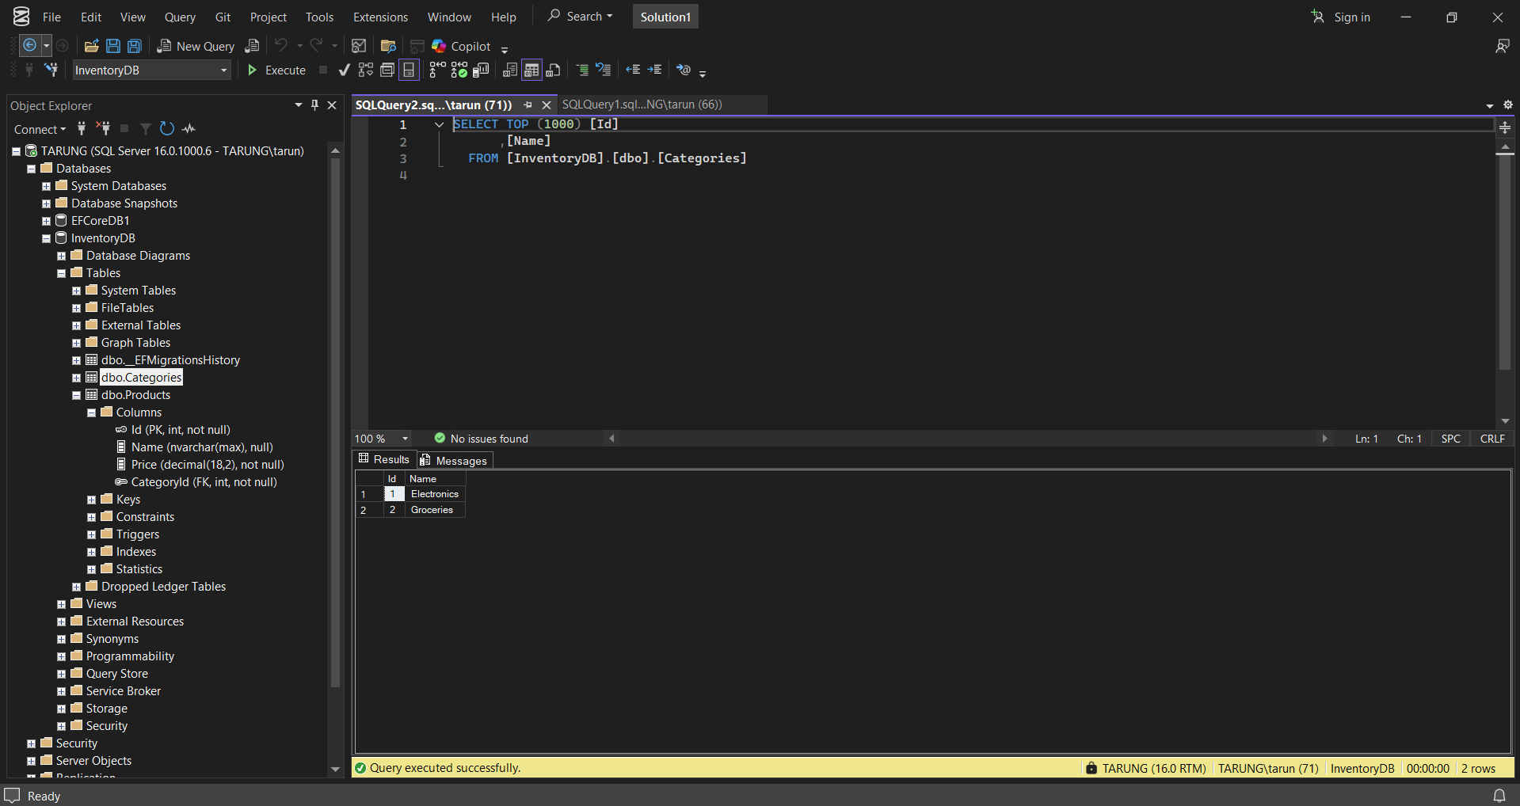

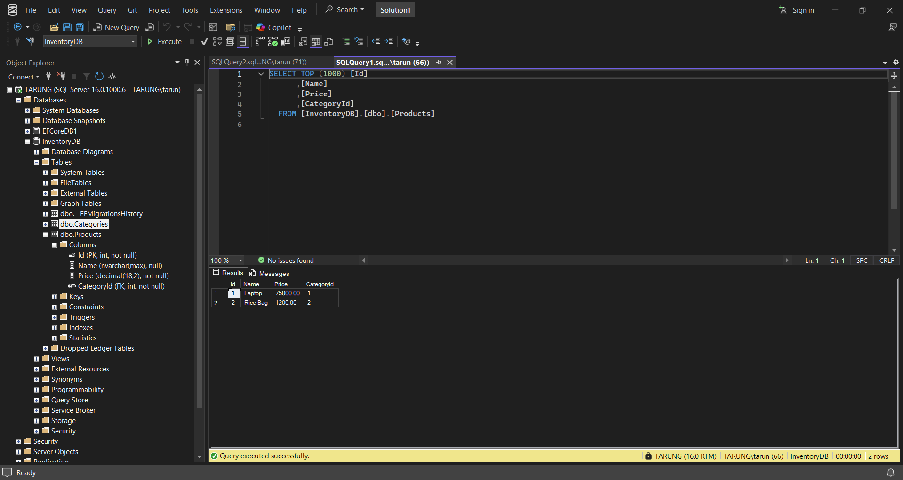

**Lab 5: Retrieving Data from the Database**

**Scenario:** The store wants to display product details on the dashboard.

**Objective:** Use Find, FirstOrDefault, and ToListAsync to retrieve data.

**Steps:**

**1. Retrieve All Products:**

var products = await context.Products.ToListAsync();

foreach (var p in products) Console.WriteLine($"{p.Name} - ₹{p.Price}");

**2. Find by ID:**

var product = await context.Products.FindAsync(1); Console.WriteLine($"Found: {product?.Name}");

**3. FirstOrDefault with Condition:**

var expensive = await context.Products.FirstOrDefaultAsync(p => p.Price > 5000 0);

Console.WriteLine($"Expensive: {expensive?.Name}");

**Implementation:**

